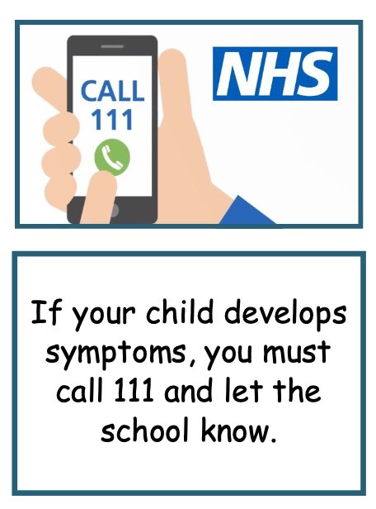

We have rigorous cleaning in place to keep children safe.

School starts on Thursday 3rd September for **all** pupils.

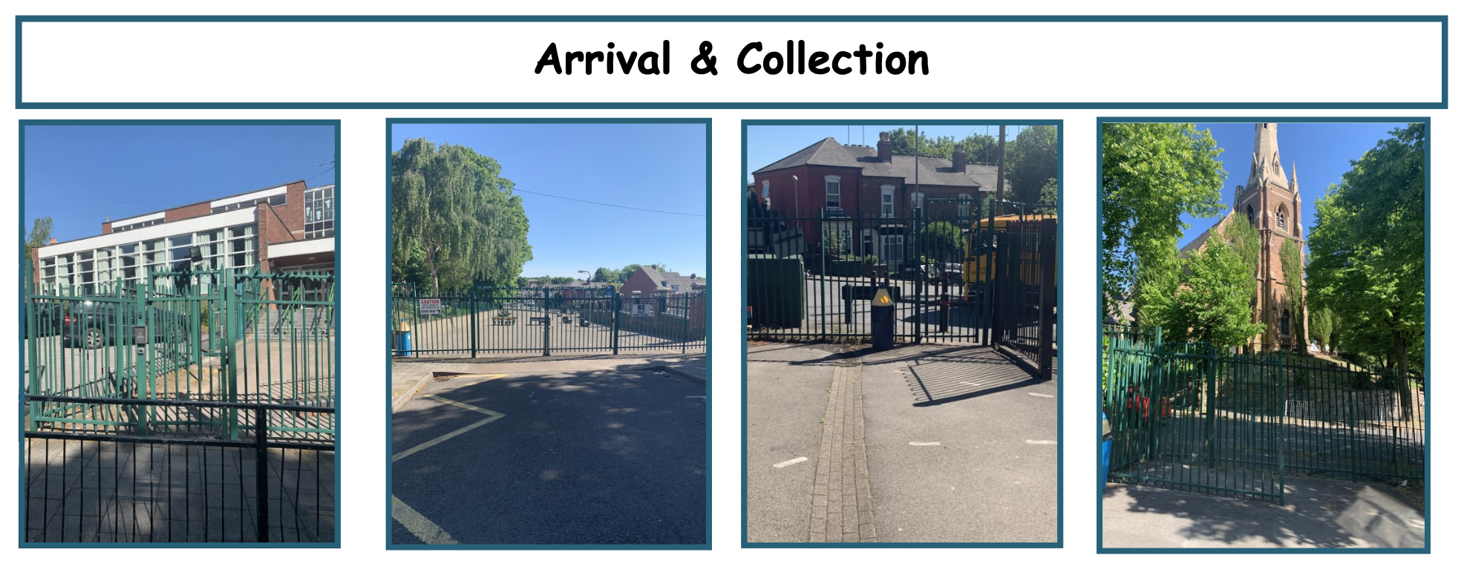

**Communication**

Parents and visitors cannot come into school, unless it is arranged appointment. Any letters, money etc. need to be placed in your child’s bag and these will be sent to the office.



[This Photo](https://en.wikipedia.org/wiki/File:Regulatory_road_sign_no_entry_for_pedestrians.svg) by Unknown Author is licensed under [CC BY-SA](https://creativecommons.org/licenses/by-sa/3.0/)

**Years 3 & 4**

Start: 08:45

Finish: 15:10

**Years 1 & 2**

Start: 08:50

Finish: 15:15

**Reception**

Start: 08:55

Finish: 15:15

**Years 5** **& 6**

Start: 08:30

Finish: 15:00

**Start & End Times**

Years 2, 4 and 6 will enter via the gate on St. Michael’s Hill Road entrance and line up.

Years 1, 3 and 5 enter via these gates on Piers Road or Scholars Close. Children will line up on the playground.

Reception enter via this gate and make their way to the Reception classroom along the path.